Roland VT-4 Companion Application

# Introduction

**Roland VT-4**, Voice Transformer version 4, is a very competent piece of equipment.

It has five effects: Robot, Megaphone, Vocoder, Harmony, and a reverb/delay effect. All effects can be combined, and there are eight pre-programmed effect sets, called **scenes**, that can be called up.

However, the manual does not tell you all about what you can do with your VT-4, and it is also sometimes not so easy to adjust settings. Some of the settings are not even available from the VT-4 front panel!

With the **Roland VT-4 Companion Application** you can access all settings, and much easier than by using the VT-4 front panel. All you need to do is to connect you VT-4 via a USB cable to your computer, and then start the Roland VT-4 Companion Application. This is what it looks like:

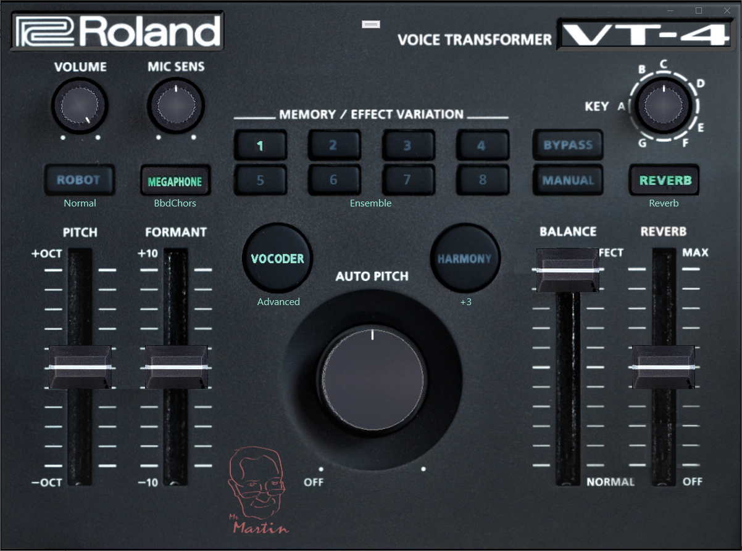

The controls in the app does essentially the same things as the controls on you device, but they are easier to use.  
Still, I urge that you read the VT-4 manual in order to be able to fully understand and utilize your VT-4. Some more complicated settings procedures are done much easier in the app where you have a system menu available if you click on the Roland logo. Also note that you have direct access to all eight scenes since the application has eight scene buttons. However, the VT-4 does not expose all settings via MIDI, so there are a few that has to be set manually from the front panel, those who involve power cycling and use of the Key knob.

To be able to access all functions you need a mouse with at least three buttons.

Left button is used to toggle effects, click buttons, turn knobs and drag sliders. Just left click on Robot, Megaphone, Vocoder, Harmony and the Reverb buttons to activate/deactivate an effect, on a Memory / Effect Variation button to select a scene, or on the manual button to go to manual mode.

Right button is used for bringing up a menu. Using it on the Memory / Effect Variation buttons allows you to save your settings or copy scenes. Used on an effect button shows a menu where you can select an effect **variation**. Note that the VT-4 has eight variations, not four as stated in the VT-4 manual. You can access all eight variations also from the VT-4 panel if you also use the Manual button to access the variations five to eight. This is interesting if you plan to make changes in the variations and later want to access them using the front panel, e.g. when using it on stage.

Any other mouse button is for selecting a menu with the effect settings for the selected effect and variation. Some effects have different set of parameters depending on the selected variation.

Right mouse button opens a variations menu: Any other mouse button opens a parameter menu:

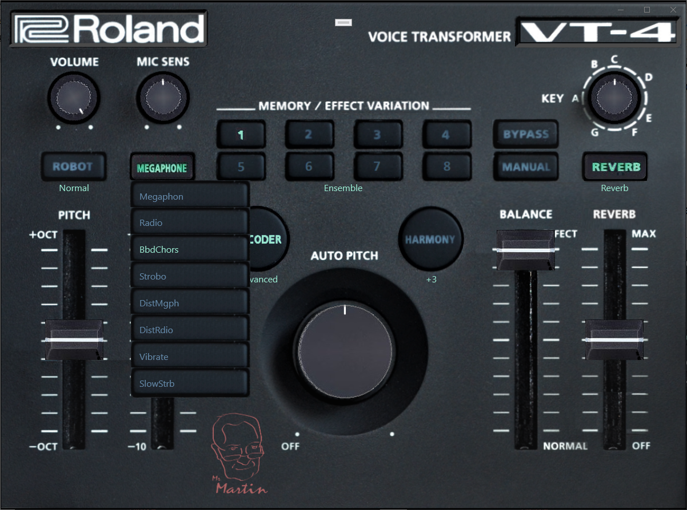 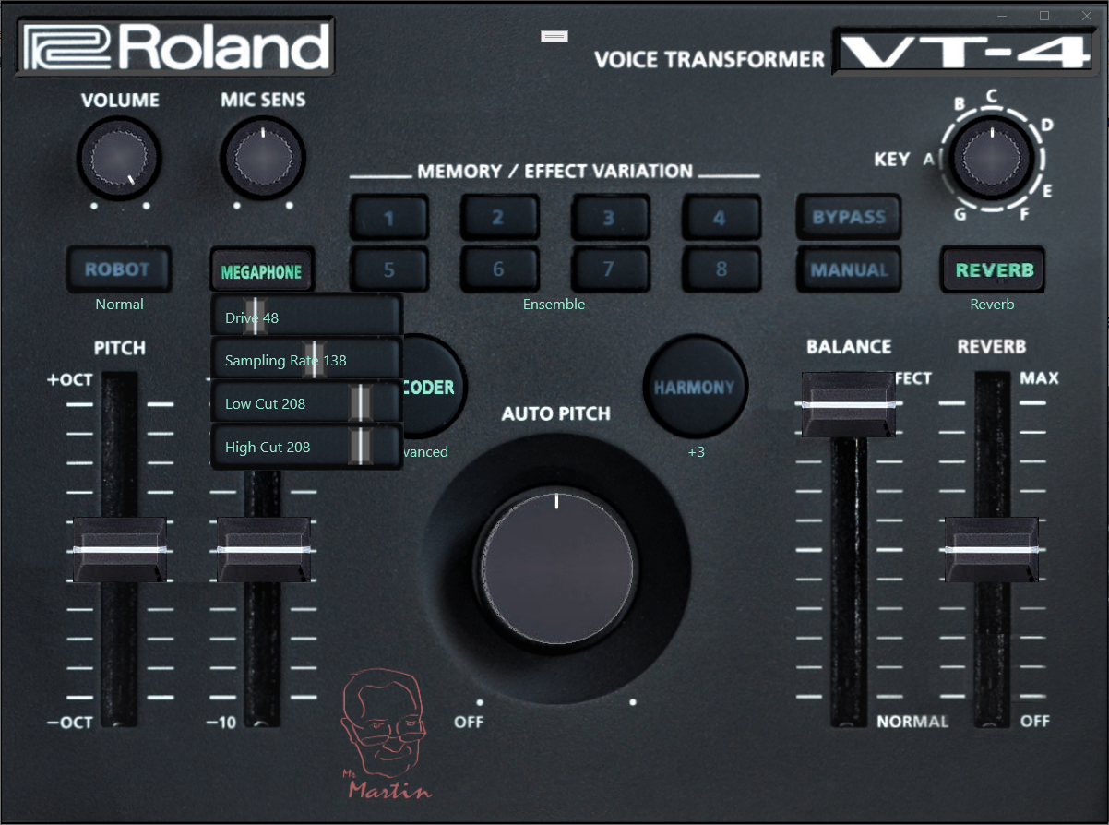

Knobs and sliders can be dragged to change an effect. They also follow your VT-4 should you turn/drag the physical knobs and sliders. Knobs and sliders can also be fine adjusted by turning the mouse wheel.

Most buttons has one or more menu. The knobs and sliders do not. Knobs and sliders are handled by pressing the left mouse button and dragging up, for higher values, or down, for lower values, and by turning the mouse wheel. You can make the mouse wheel change faster by simultaneously holding down left, right or both mouse buttons.

Most menu items also have slider handles to let you change settings, while a few acts as on/off buttons.

So, the technicians at Roland supplied eight variations of each effect. But the manual only mention four of them. Now you can use and also edit all eight variations as much as you like. And you can save your entire setup as a file on your computer.

The scene buttons calls up settings where one or more effects are combined. This includes the setting of the sliders as well. Each effect has preprogrammed settings called Variations. Settings and Variations are stored in the devices memory. You can see the memory layout in the MIDI Implementation manual, where the scenes are called ‘Patches’. Each one of the eight scenes holds settings for all effects and all sliders plus the Key and Auto Pitch knobs. System settings are not stored in scenes.

If you hesitated to elect to buy a VT-4 rather than the VT-3 because of the deeper reverb of the VT-3, you can now use reverb variation five to get a deeper reverb. With **Roland VT-4 Companion Application** you can adjust the preset values that give a variation its character. Reverb variation five can have a feedback strong enough to let your voice reverberate forever! Actually, you can change any variation the way you like, so e.g. the first variation, Reverb, can also be edited the same way. Some effects, however, has different ‘engines’ for some variations thus also has different parameter names.

So, the VT-4 has eight setup memories, called ‘scenes’, into which you can save your setups. The scenes store the following settings:

* Effect on/off/MIDI in for Robot.
* Effect on/off for Megaphone, Vocoder and Harmony.
* Selected variation for Robot, Megaphone, Vocoder, Harmony and Reverb.
* Slider settings for Pitch, Formant, Auto Pitch, Balance and Reverb.
* Parameter values for all effects.
* Key and Volume.

Note that the VT-4 Robot can accept up to three notes from a keyboard. Singing one tone in the microphone allows you to hear them as a choir with pitches from the keys you press on the keyboard.

The VT-4 has five effects that can be turned on and off as you like, or set when selecting a scene. If all effects are turned off, the VT-4 still applies all system settings. Those are:

1. MIC SENSE, input volume for the microphone.
2. LOW CUT, a high pass filter that removes low frequencies.
3. GATE, a feedback protection circuit.
4. EQUALIZER, well, an equalizer of course.
5. LIMITER, a circuit that limits the volume of incoming signal to help the effects to work properly.

You can always use the balance slider to hear how the above affects your output sound.

Some notes about using the VT-4 front panel when the VT-4 companion application is active. Most changes done are reflected in the application user interface, with a few exceptions.

As mentioned above, not all settings can be communicated via MIDI, like the application does. There are also a few settings that it is not possible to query the VT-4 for, the four knobs. Therefore, they are not set right after the program starts. However, turning a knob will also update the application, just like the sliders.

The application uses the buttons press/release messages transmitted via MIDI, but the Manual button does not transmit the release message. This is unfortunate because when the application receives a press Manual button, it has no way to know whether the key is released or not in case a scene button press follows. If it is, the VT-4 will select a scene in the range one to four, if not, it will select a scene in the range five to eight.

The application has a workaround for this. Is assumes that the Manual button is pressed down for five seconds, and then released. In order to alert the user of the fact that a press on a scene button can be misunderstood, all eight scene buttons will blink during those five seconds.

# The internal workings of the VT-4

In order to fully take advantage of the VT-4’s effects, you also need to fully understand its internal workings.

We could divide the VT-4 into three categories of internal parts and their settings:

1. **System** parts and settings, like microphone sensitivity, MIDI channel, and gate level etcetera.
2. **Scenes**, where effects are turned on/off and the front panel settings are stored.
3. **Variations**, where the settings for each effect are set.

System parts are fairly straight forward, but we need to take a look at **scenes** and **variations**.

You can select a scene from the front panel by pressing one of the buttons 1 – 4 to bring up scene 1, 2, 3 or 4, or by pressing and holding the MANUAL button while pressing one of the buttons 1 – 4 to bring up scene 5, 6, 7 or 8. You can also select a scene from the Roland VT-4 Companion Application by left-clicking one of the buttons 1 – 8.

When you select a scene the following happens:

The scene memory corresponding to the scene you selected is copied to a temporary scene memory. Then the variations for all effects, Robot, Megaphone, Vocoder, Harmony and Reverb are copied from the corresponding memory to temporary variation memories.

The VT-4 then operates using the temporary memory areas, and if you make any changes, they are changed only in the temporary memory areas. Thus you can experiment with the settings without changing the default settings.

Note that a variation is only a set of parameters for an effect. Some effects have different interpretation of the settings depending on the selected variation itself. See under ‘Variation parameters’ later in this document.

Page 6 in Roland manual explains how to save a scene. If you save a scene into one of the slots 1 – 8, the settings that were in that slot will be overwritten. Your TV-4 is no longer setup as from the factory. This is probably what you want to do, because you want to make your own scenes to your own liking. If you later want to get the factory settings back, the manual explains how to do a factory reset on page 10 of the Roland VT-4 manual.

If you look at page 11 in the Roland manual, you can see how you can select alternate variations for the different effects. All effects are limited to four different variations, according to the manual, but in the MIDI implementation document it is obvious that the reverb has six different variations. Using the Roland VT-4 Companion Application lets you select from all those six variations, and you will find that the variation ‘Deep reverb’ has a much deeper reverb than you can normally get out of your VT-4. In fact, the VT-3 seems to have a better reverb than the TV-4, but when using ‘Deep reverb’ that is no longer true. (Note that the names can be changed, so ‘Deep reverb’ might not be what it is called.)

Actually, the MIDI implementation allows for selecting from eight variations for all effects. I have made all eight variations available in the Roland VT-4 Companion Application. I have simply called the undocumented variations ‘Variation 1’ etcetera. You can change those names as you like. See more about that under ‘Naming’.

Variation lists from the manual: Variation list from the MIDI implementation:

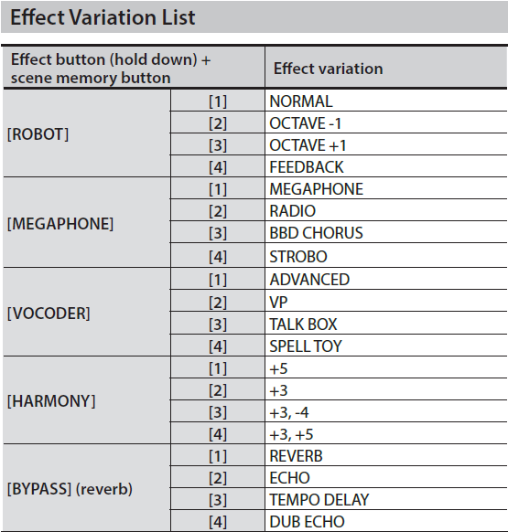 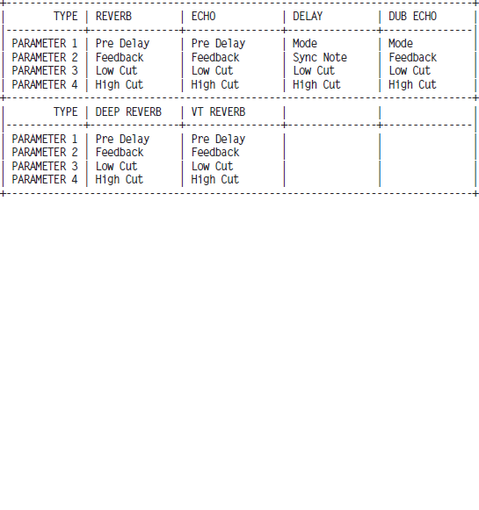

Right-click on the Bypass button on the Roland VT-4 Companion Application to see a list of variations for the reverb:

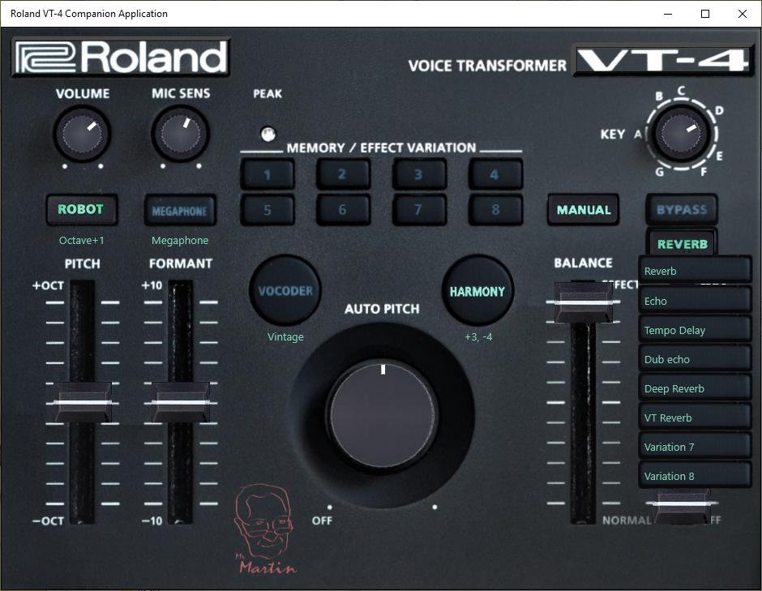

Saving and loading a scene by using the front panel buttons of the VT-4 also saves all variations, but you cannot edit the variations from the front panel. However, the Roland VT-4 Companion Application allows you to adjust the settings for each variation. Note that changes in variations are saved when you save a scene.

Use a third mouse button (any button except left and right button) on an effect button to open settings for the variations of the effect (for reverb, click on the Bypass button). Note that the effect must be turned on (left-click for on/off):

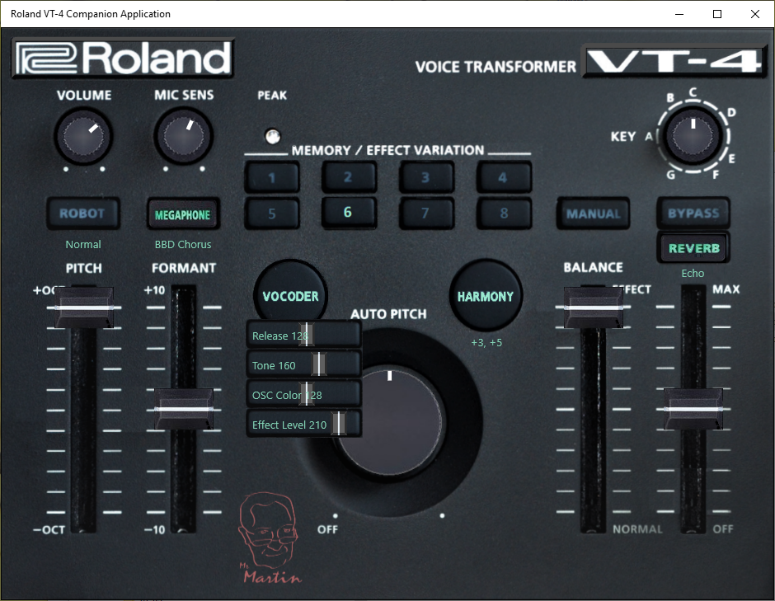

Right-click on a scene button for a save/copy menu:

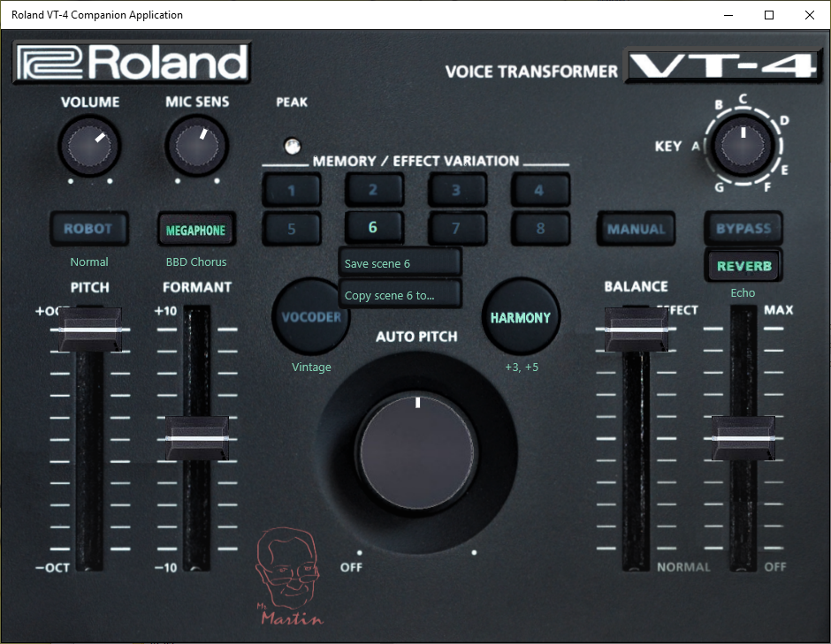

# Scenes and variations

**Scenes** contain settings you can do on the front panel, and in the Roland VT-4 Companion Application, of course:

1. Effects on/off.
2. Sliders.
3. Auto pitch knob.
4. Key knob.

Scenes also contain information about which **variation** of each effect is selected, but not the settings of the variation.

**Variations** contain settings for an effect. The settings are default from factory settings, and cannot be changed from the VT-4 front panel. However, the Roland VT-4 Companion Application lets you change the setting as you like.

**Note!** The settings for a **variation** change the effect, but the effect can be used in any **scene**. This means that if you change the setting for a variation, it will be changed for all scenes that uses the effect. The VT-4 does not allow for different variation settings in different scenes. The whole idea is to have different variations selected in different scenes, and that should suffice since you actually have eight variations for each effect.

# Naming

All **variations** can have names. There is room for those names in the memory of the VT-4, but those names are not used, as far as I can find. They are also limited to eight characters, which I find too little to create a name that fully describes the variation. It seems like Roland had some intention to use them, e.g. by adding a display for names, but since I found that not all names were actually filled in, I believe they abandoned that idea.

There are three sources for names:

1. The default names in the memory, as mentioned above.
2. There are some names in the MIDI implementation name, and I have used them as default names.
3. You can enter new names yourself.

To enter a name yourself, right-click an effect button to bring up the variations menu. Right-click the variation you want to rename, and type a new name. Your name will be saved when you save the variation, which will be saved when you save a scene. The name is not stored in the VT-4, and that would be useless since it cannot display names. The application saves the names in its local store instead.

Since the system menu has an option to save/load your entire setup on files in your computer, you can create many different sets of scenes and variations and name the file as you wish. According to the manual, you can also save the setup from the VT-4 front panel, but note that the file format differs. The application uses a .json format that lists all settings in a way that is easy to read with a common text editor, like notepad.

# System settings

It is possible to edit system settings from the front panel of the VT-4, but it is a bit complicated. You can read about it in the manual on page 8 under ‘Making Settings for Other Functions’. But the Roland VT-4 Companion Application makes it much easier, however, as mentioned above, not all settings are available for the application to change. It also allows you to save/load all your settings to/from a file on your computer.

Right-click on the Roland logo for a system menu: Left-click to select MIDI channel:

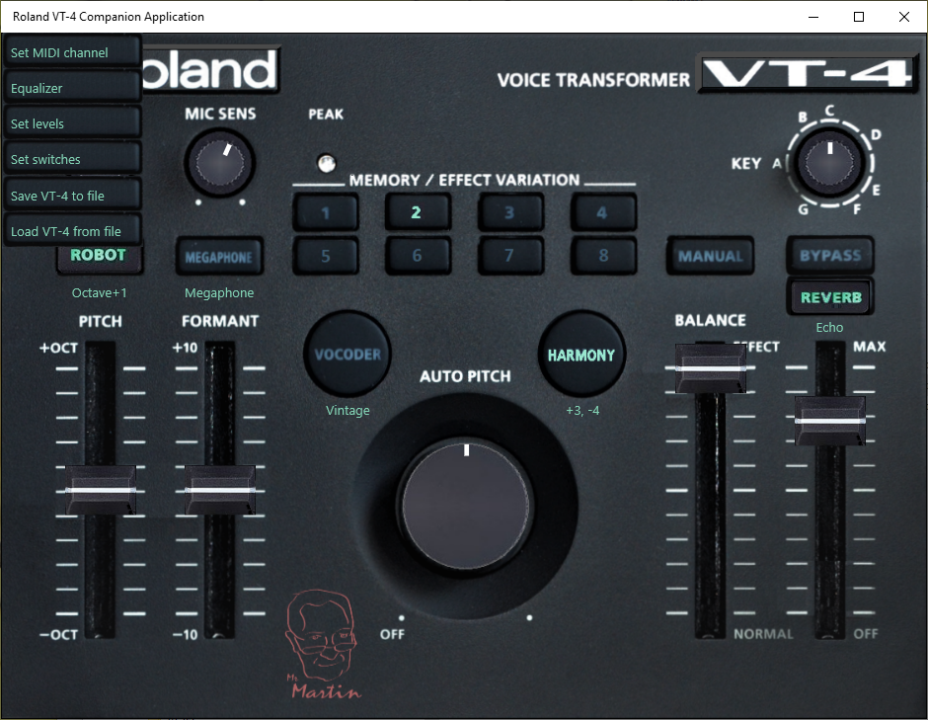 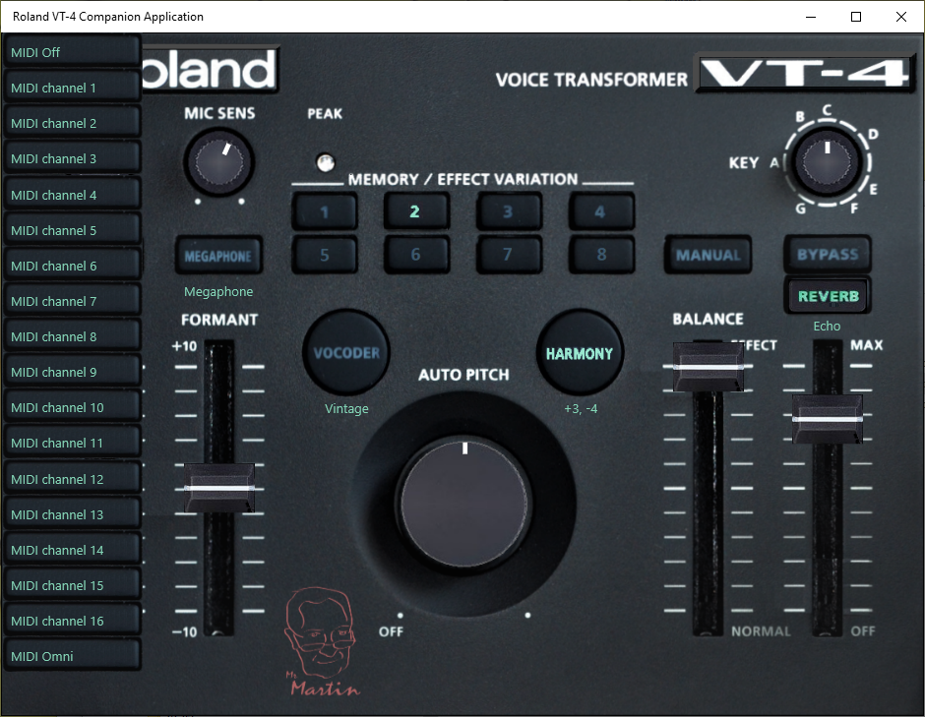

Left click on the VT-4 logo to open this manual (you need Adobe pdf viewer to read it).

# Robot

Left-click the Robot button to turn robot on or off.

Right-click the Robot button to select robot variation (note that Robot must be turned on):

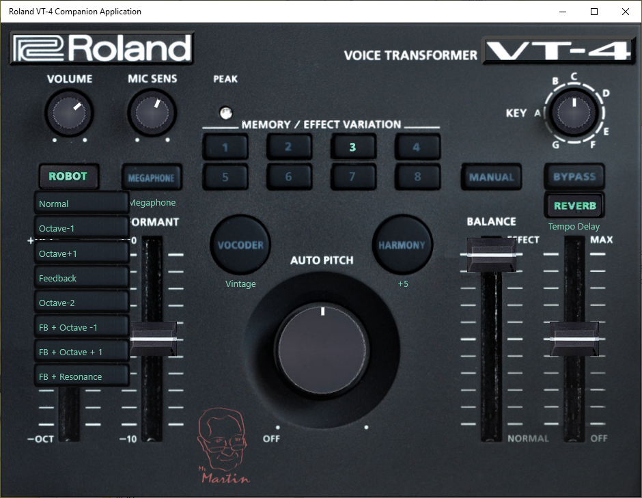

As you can see there are actually eight pre-programmed variants of Robot, not four as the manual states.

Robot creates an effect where your voice is held at a fixed pitch, which seemed to be around 294 Hz when I compared mine with my guitar. That would be a middle D on the piano keyboard. The pitch can be adjusted up or down using the PITCH slider, on the VT-4 front panel or dragging the corresponding slider handle on the Roland VT-4 Companion Application.

You can also use the Roland VT-4 Companion Application to change the fixed pitch down 1 or 2 octaves or up one octave.

In addition to the fixed pitch Robot can also apply feedback to the sound.

You can alter the variation to your liking. Just click the Robot button with any mouse button *except* right or left button, e.g. middle button (note that Robot must be turned on):

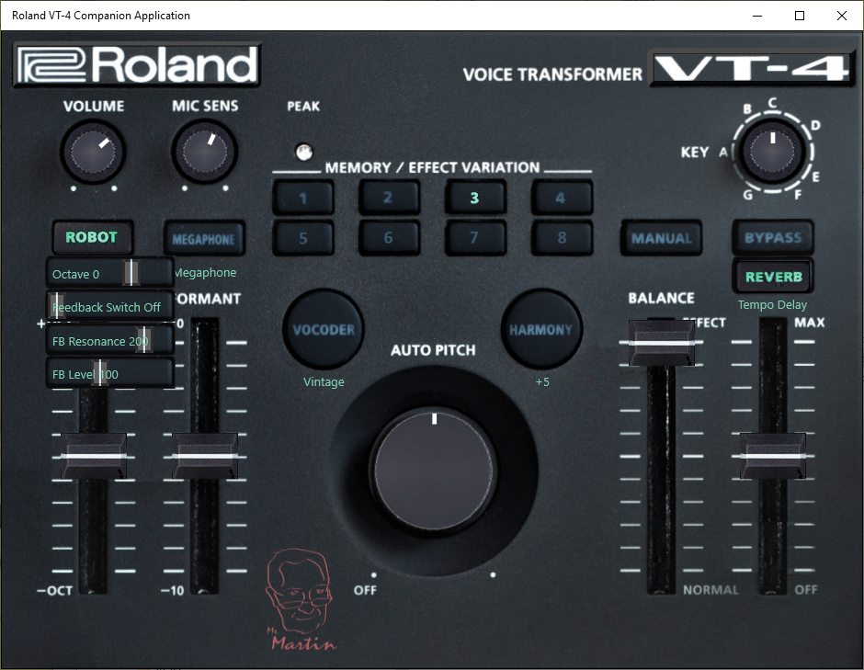

You can now make your own variation by changing:

1. Octave to get a higher or lower pitch. Pitch slider still works around the selected octave.
2. Turn feedback on or off.
3. Set feedback resonance level.
4. Set feedback level.

Note: The labels you see on the previous menu, ‘Normal’, ‘Octave -1’ etcetera, will not be changed to reflect your new settings. If you e.g. alter the ‘Normal’ variation to be something else than normal robot, the menu text will still be ‘Normal’. Read the paragraph ‘Naming’ above to see how you can change the name.

# Megaphone

Megaphone creates a distorted sound to mimic someone talking in a megaphone. It can also be used for other similar distortions:

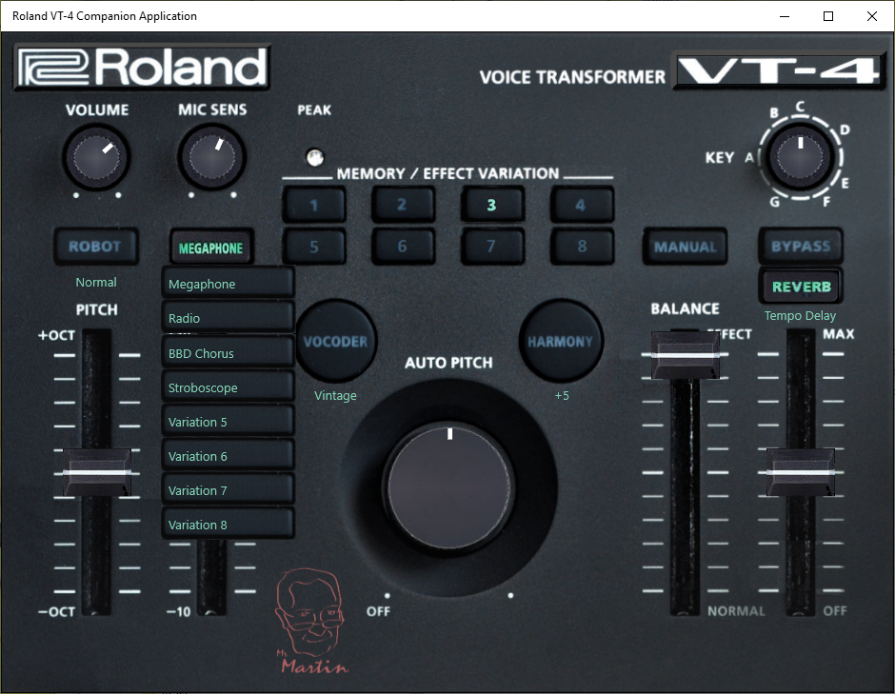

# Vocoder

The vocoder creates a sound similar to computer generated speech.

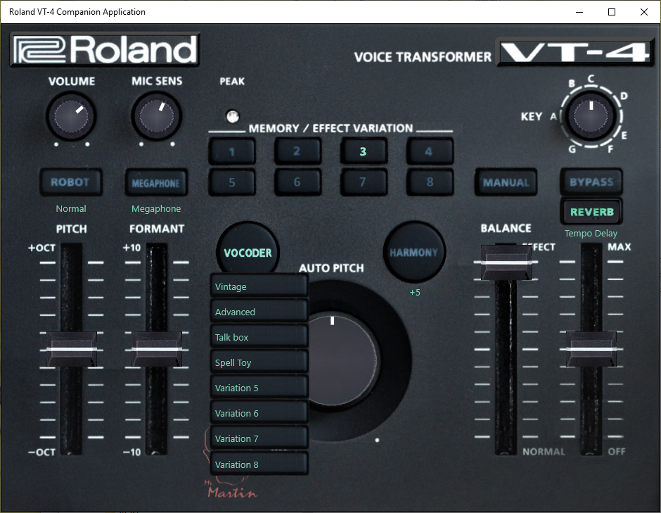

# Harmony

Harmony adds up to three transposed tones to make it sound like you are singing in a choir. If you connect a MIDI keyborard via the 5-pin connector, the harmony effect changes to transform your voice to any chord pressed on the keyboard.

The Auto pitch knob will let you force your voice more or less to fit into the key set by the key knob.

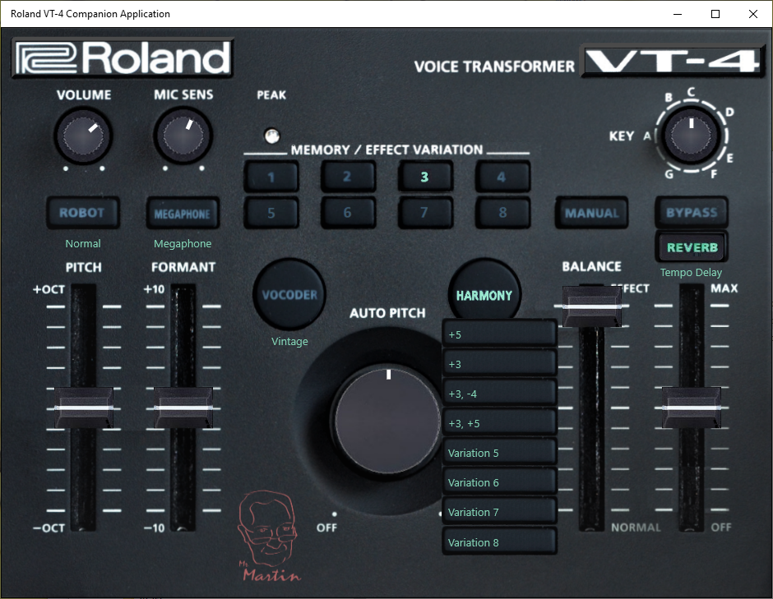

# Reverb

The reverb creates a lingering sound like when you are in a room where the walls reflects your voice.

This effect also has a delay function that creates an echo effect.

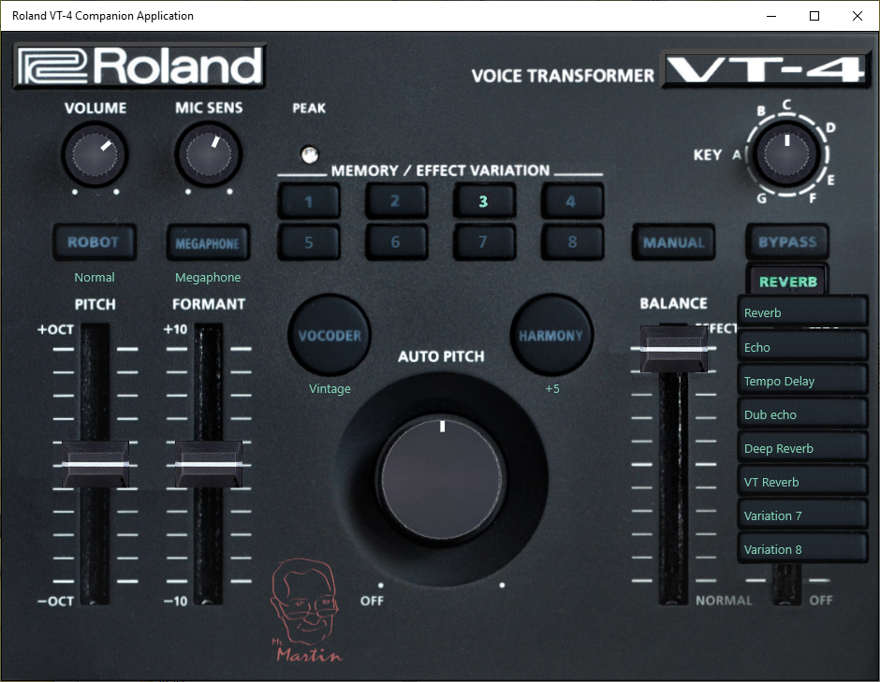

# Variation parameters

Some effects have different settings depending on selected variation. Robot, Harmony does not, but Megaphone, Vocoder and Reverb does, and they are listed below. (‘TYPE’ in the tables is what we call ‘variation’.)

Megaphone:

|  |  |  |  |  |
| --- | --- | --- | --- | --- |
| TYPE | MEGAPHONE | RADIO | BBD CHORUS | STROBO |
| PARAMETER 1 | Clip Gain | Drive | Mode | Wave Shape |
| PARAMETER 2 | Direct Level | Sampling Rate | Depth | Rate |
| PARAMETER 3 | Volume | Low Cut | Effect Level | Depth |
| PARAMETER 4 | - | High Cut | Noise Level | Level |

Vocoder:

|  |  |  |  |  |
| --- | --- | --- | --- | --- |
| TYPE | VINTAGE | ADVANCED | TALK BOX | SPELL TOY |
| PARAMETER 1 | Release | Release | Release | Release |
| PARAMETER 2 | Tone | Tone | Formant Depth | Tone |
| PARAMETER 3 | Consonant | OSC Color | OSC Color | OSC Color |
| PARAMETER 4 | Effect Level | Effect Level | Effect Level | Effect Level |

Reverb:

|  |  |  |  |  |  |  |
| --- | --- | --- | --- | --- | --- | --- |
| TYPE | REVERB | ECHO | DELAY | DUB ECHO | DEEP REVERB | VT REVERB |
| PARAMETER 1 | Pre Delay | Pre Delay | Mode | Mode | Pre Delay | Pre Delay |
| PARAMETER 2 | Feedback | Feedback | Sync Note | Feedback | Feedback | Feedback |
| PARAMETER 3 | Low Cut | Low Cut | Low Cut | Low Cut | Low Cut | Low Cut |
| PARAMETER 4 | High Cut | High Cut | High Cut | High Cut | High Cut | High Cut |